History

It is a musical form and a music genre that started in African-American communities of the “Deep South” of the United States around the end of the 19th century. It is inspired by mainly spirituals, work songs, filed hollers, shouts and chants and rhymed simple narrative ballads.

About

It has been around for over 100 years and has influenced all kinds of other genres, such as, rock and jazz. It has originated in the Southern United States. The three main instruments being guitar, banjo and the harmonica. It is usually slow and sad, due to the fact that it is inspired by real life stories. It comes straight from the heart, from the soul and it’s based on how you feel on a certain event. It is about wallowing in negativity and despair. The best blues is visceral, cathartic, and starkly emotional. From unbridled joy to deep sadness, no other form of music can communicate a more genuine emotion. Anything is possible with the blues.

Additional quote

"The blues takes many forms... It is variously a feeling, a mood, a nameless threat, a person, a lover, a boss man, a mob, and, of course, the Devil himself. It is often experienced as cause and effect, action and reaction, and it can be used as both hex and counterhex, poison and antidote, pain and relief. Most importantly, the blues is both the cause of song, and song itself..." - Edward Comentale

Introduction

Blues have something very similar to most music genres such as, jazz, rock and roll, heavy metal music, hiphop music, reggae, country music and pop music. They have all been accused of being the “devil’s music” and of inciting violence and other poor behaviors. However, in the early twentieth century, W.C. Handy was the first to popularize blues to the non-black Americans.
What’s the difference between jazz and blues?

Blues is a simpler and more rigidly structured form of music than jazz. It is usually intended to convey a feeling of sadness and use simple chords.

- The instrumentation - blues originated from African Americans and is both vocal and instrumental and based on blue notes for the repetitive pattern which follows a twelve-bar structure. It’s first and foremost vocal and is technically defined by a 1-4-5 chord sequence with a 12-bar motif.
- As for Jazz originated from America. It is a continuation of blues music with a marching band. The type of instruments that are used in jazz are saxophones, trumpets, pianos, double bass and drums. It is primarily an instrumental style and contains heavy syncopation. Jazz will only follow the form of which it was written and it allows free improvisation.
Scale

A major feature of the blues scale is the use of blue notes, however, they are considered as alternative inflections. A hexatonic scale is a scale with six pitches (or notes). The only common scales are the blues scale and the whole tone scale.

Examples:
The whole tone scale:
C D E F A B C

The half-step intervals for these two scales are:
for these two scales are:
- Whole Tone: 2-2-2-2-2-2
- Blues: 3-2-1-1-

Muddy Waters is considered as the father of modern Chicago blues and was an inspiration for the British blues explosion of the 1960s. In 1940, Muddy Waters moved to Chicago and played with Silas Greena year later. When he returned to Mississippi, he ran a juke joint, gaming, moonshine and a jukebox and performed music there himself. 3 years later, he went back to Chicago, hoping to become a full-time professional musician and he started opening Big Bill Broonzy’s shows in the rowdy clubs.

The Rolling Stones are an English rock band that was formed in London in 1962. They were also instrumental in making blues a major part of rock and roll and changing the international focus of blues culture to the less sophisticated blues typified by artists such as Muddy Waters. They started out as a blues cover band in 1962, and even though they had some pop and reggae touches, the blues was always the touchstone. The Rolling Stones were received as symbols and leaders of rebellious youth. Their musical styles include blues, rhythm and blues, country, folk, reggae, dance and world music. They started out covering early rock ’n’ roll and blues songs. They admired Jimmy Reed, Muddy Waters, and Little Walter. When Keith Richards first listened to Muddy Waters, he recalled it was the most powerful music he had ever heard - the most expressive. However, they didn’t just sit around and listened to blues, they listened to everything.
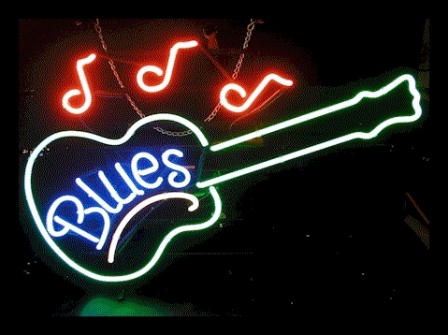

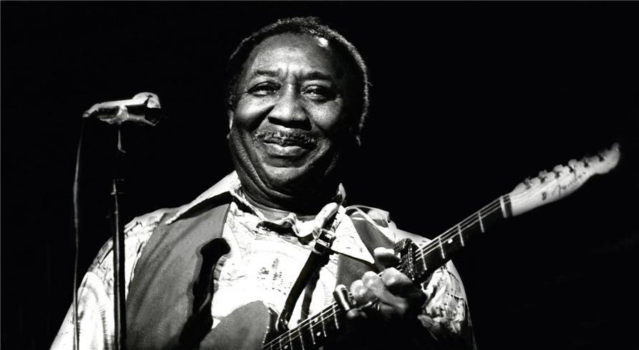

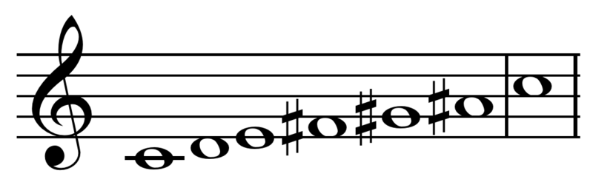
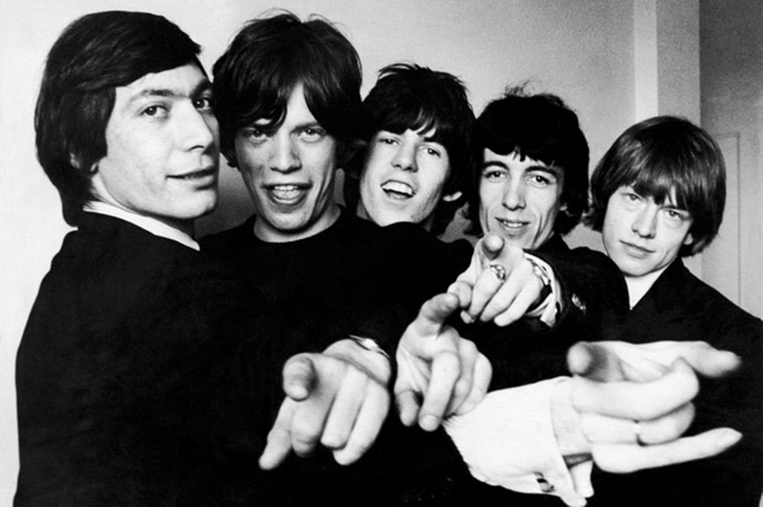

Works Cited
"A Brief History of the Blues." All About Jazz. N.p., n.d. Web. 12 Jan. 2014. <http://www.allaboutjazz.com/php/article.php?id=18724&pg=2#.UtTPHnk1FfM>.
"Blues." Wikipedia. Wikimedia Foundation, 1 Dec. 2014. Web. 13 Jan. 2014. <http://en.wikipedia.org/wiki/Blues>.
"Blues Music History Summary & Analysis." Shmoop. N.p., n.d. Web. 12 Jan. 2014. <http://www.shmoop.com/blues-history/summary.html>.
"Blues scale." Wikipedia. Wikimedia Foundation, 13 Jan. 2014. Web. 14 Jan. 2014. <http://en.wikipedia.org/wiki/Blues_scale>.
"Difference Between Jazz and Blues | Difference Between | Jazz vs Blues." Difference Between Jazz and Blues | Difference Between | Jazz vs Blues. N.p., n.d. Web. 14 Jan. 2014. <http://www.differencebetween.net/miscellaneous/culture-miscellaneous/difference-between-jazz-and-blues/>.
"Muddy Waters." Wikipedia. Wikimedia Foundation, 1 Aug. 2014. Web. 14 Jan. 2014. <http://en.wikipedia.org/wiki/Muddy_Waters>.
"What Is the Difference between Jazz and the Blues?." What Is the Difference between Jazz and the Blues. N.p., n.d. Web. 14 Jan. 2014. <http://www.ask.com/question/what-is-the-difference-between-jazz-and-the-blues>.
"What is the difference between blues and jazz?." Yahoo! Answers. Yahoo!, n.d. Web. 14 Jan. 2014. <http://answers.yahoo.com/question/index?qid=20080126220259AANhgco>.
"what is the difference between Jazz and Blues?." Yahoo! Answers. Yahoo!, n.d. Web. 14 Jan. 2014. <http://answers.yahoo.com/question/index?qid=20080407193725AAMMg8J>.

